St10317969

Kgotatso phetoe

PROG6212 PART 2

Github : https://github.com/Kgotatso123/prog6212part2.git

Below is a User Manual for MY ASP.NET Core MVC Lecturer Claims Application, which includes sections on how to access, navigate, and use all key functionalities of the application.

Introduction

Welcome to the Lecturer Claims Application This web-based platform allows lecturers to submit work-related claims, and managers to approve or reject those claims. The application supports a streamlined approval workflow and keeps track of each claim's status. This manual will guide you through using the system effectively.

Ensure you have the appropriate role to perform the desired action.

Creating a Claim

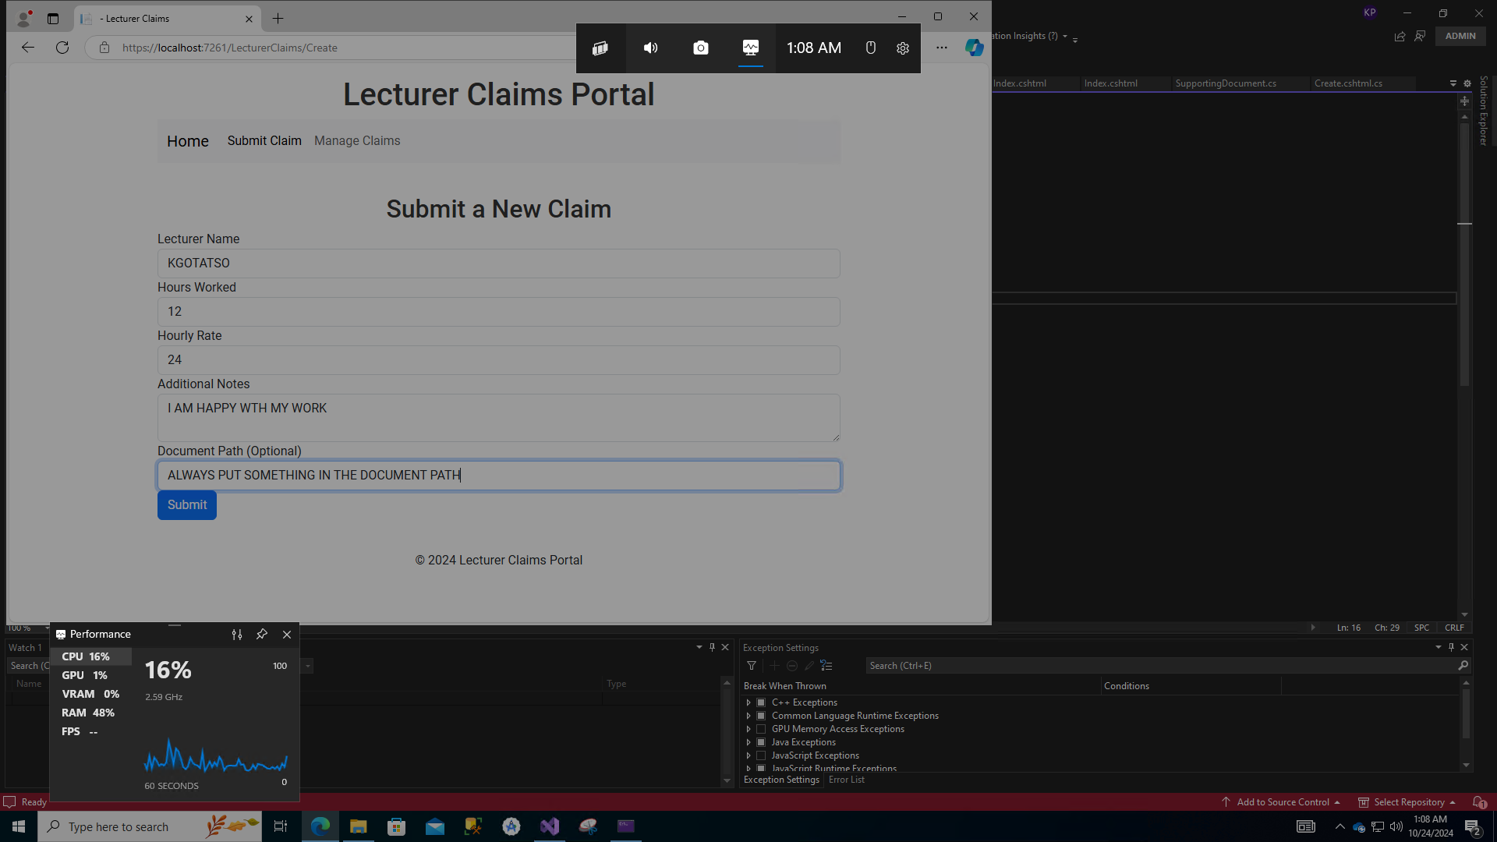

To create a new claim:

1. Navigate to the Lecturer Claims section.

2. Click the Create New Claim button.

3. Fill out the claim form:

- Lecturer Name: Enter your name.

- Hours Worked: Input the number of hours worked.

- Hourly Rate: Specify the hourly rate.

- Additional Notes: Provide any extra details relevant to the claim.

- Upload Document: Attach supporting documents (PDF, DOCX, XLSX). Ensure the file size does not exceed the allowed limit.

4. Click the Submit button.

Once submitted, your claim will be visible under the Manage Claims section with the status "Pending."

Managing Claims

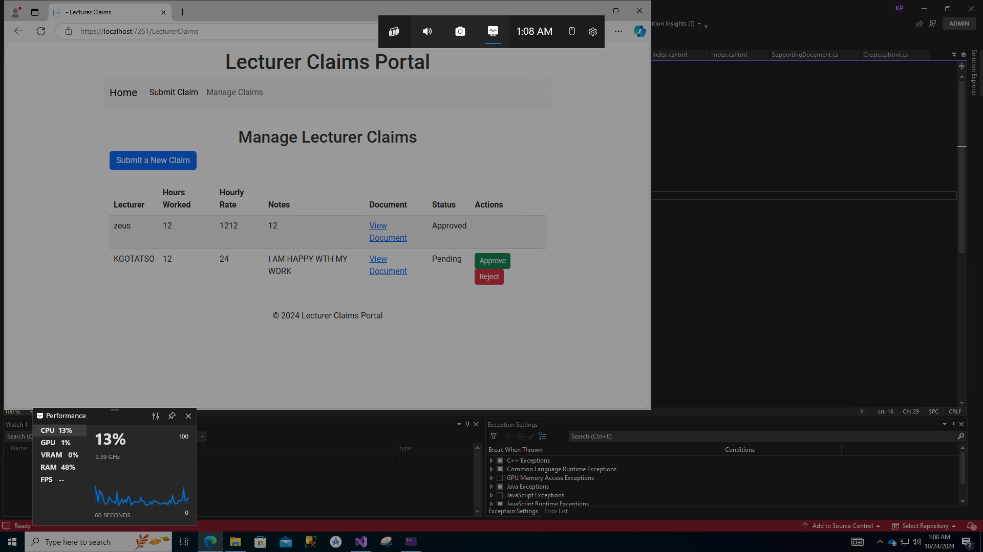

Viewing Claims

1. Go to the Manage Claims section.

2. You will see a table of claims, showing details such as:

- Lecturer name

- Hours worked

- Hourly rate

- Additional notes

- Attached document (if any)

- Current status (Pending, Approved, Rejected)

Editing a Claim(If applicable)

If you need to modify a submitted claim:

1. Click the Edit button next to the claim in the table.

2. Update the required fields.

3. Click Save.

Approving or Rejecting Claims

For users with Manager or Coordinator access:



1. Go to the Manage Claims section.

2. Locate the claim you want to approve or reject.

3. If the claim status is "Pending":

- Click the Approve button to approve the claim.

- Click the Reject button to reject the claim.

The status will update immediately upon clicking.

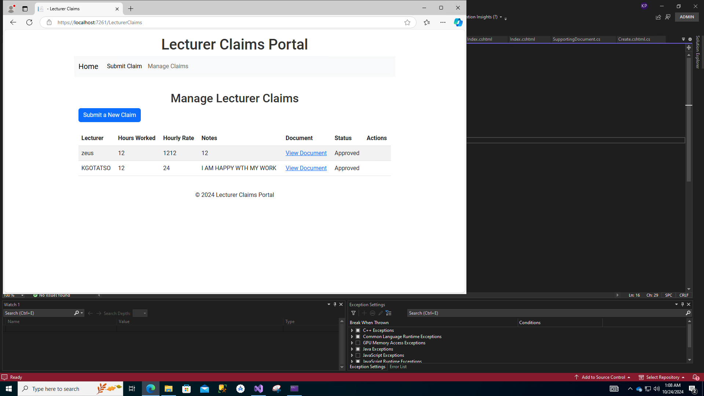

Viewing Claim Status

To track the progress of your claims:

1. Go to the Manage Claims section.

2. In the status column, view the current status:

- Pending: The claim is awaiting approval.

- Approved: The claim has been approved.

- Rejected: The claim has been rejected.

You can view the history of each claim, including the date and time of any status changes.

Troubleshooting

Here are common issues and solutions:

1. Unable to Access the Application

- Ensure you have the correct URL.

- Check your internet connection.

- Verify that the server is running (if local) by using `dotnet run`.

2. Error When Submitting a Claim

- Ensure all required fields are filled out.

- Check that your document size is within limits.

- Ensure the form does not contain any validation errors.

3. Database Issues

- Verify the database connection string in `appsettings.json`.

- Ensure that you have run the necessary database migrations (`Update-Database`).

- Make sure SQL Server or your preferred database is running.

4. HTTP 404 or 500 Errors

- Check if the URL is correct.

- Ensure that the controller and view exist and are correctly named.

- Verify routing configurations in the `Startup.cs` or `Program.cs` file.

FAQs

1. How do I reset my password?

Contact the system administrator or use the password reset functionality on the login page (if available).

2. Can I edit a claim after submission?

Editing options depend on your organization's policy. If enabled, you can edit a claim before it is approved or rejected.

3. What file types are allowed for uploads?

Allowed file types include:

-PDF (.pdf)

- Word Document (.docx)

- Excel Spreadsheet (.xlsx)

4. How can I download an attached document?

Click the View Document link in the claim details table to download and view the attached file.

5. What should I do if the application crashes?

- Restart the application using `dotnet run`.

- Check for error logs in the output console.

- Contact technical support if the issue persists.

Contact Support

If you encounter any issues not covered in this manual, please reach out to the technical support team at zeuspetoe@gmail.com

This user manual should provide a comprehensive guide for users to navigate and operate the Lecturer Claims Application effectively. Let me know if you want to customize any sections!